Links
- Poster: https://www.figma.com/design/TOC7FblF76KkeeZDGilEFy/DECO3500?node-id=165-26&t=34he9NMk0y4m5SNw-1
- Prototype:
  - https://ellie-feng.github.io/pushnpray_DECO3500/Prototype/index.html?station=printer
  - https://ellie-feng.github.io/pushnpray_DECO3500/Prototype/index.html?station=microwave

Summary
Our domain is serendipitous connections on campus. We designed two drawing tablets at campus waiting spots, a printer and a microwave, that give strangers a low-stakes way to connect by chance, in two modes:
- The message board (co-located, asynchronous) shows a location-based prompt, such as “What’s for lunch today?”, where students draw responses and see what others have left.
- Live drawing (distributed, synchronous) starts if both tablets are in use at the same moment, and the two students take turns drawing a scenario on a shared canvas until a timer runs out.
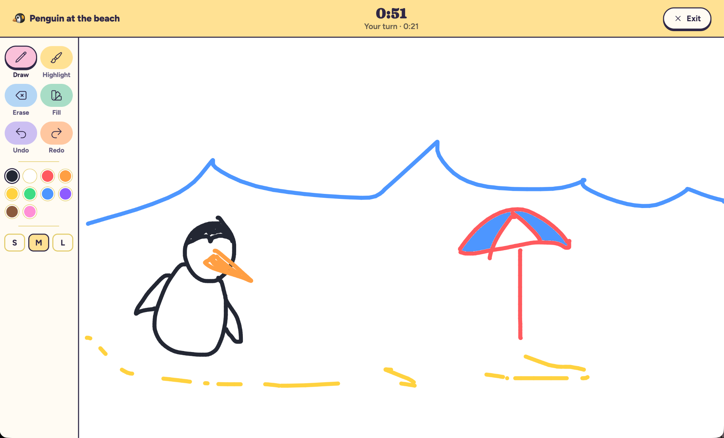
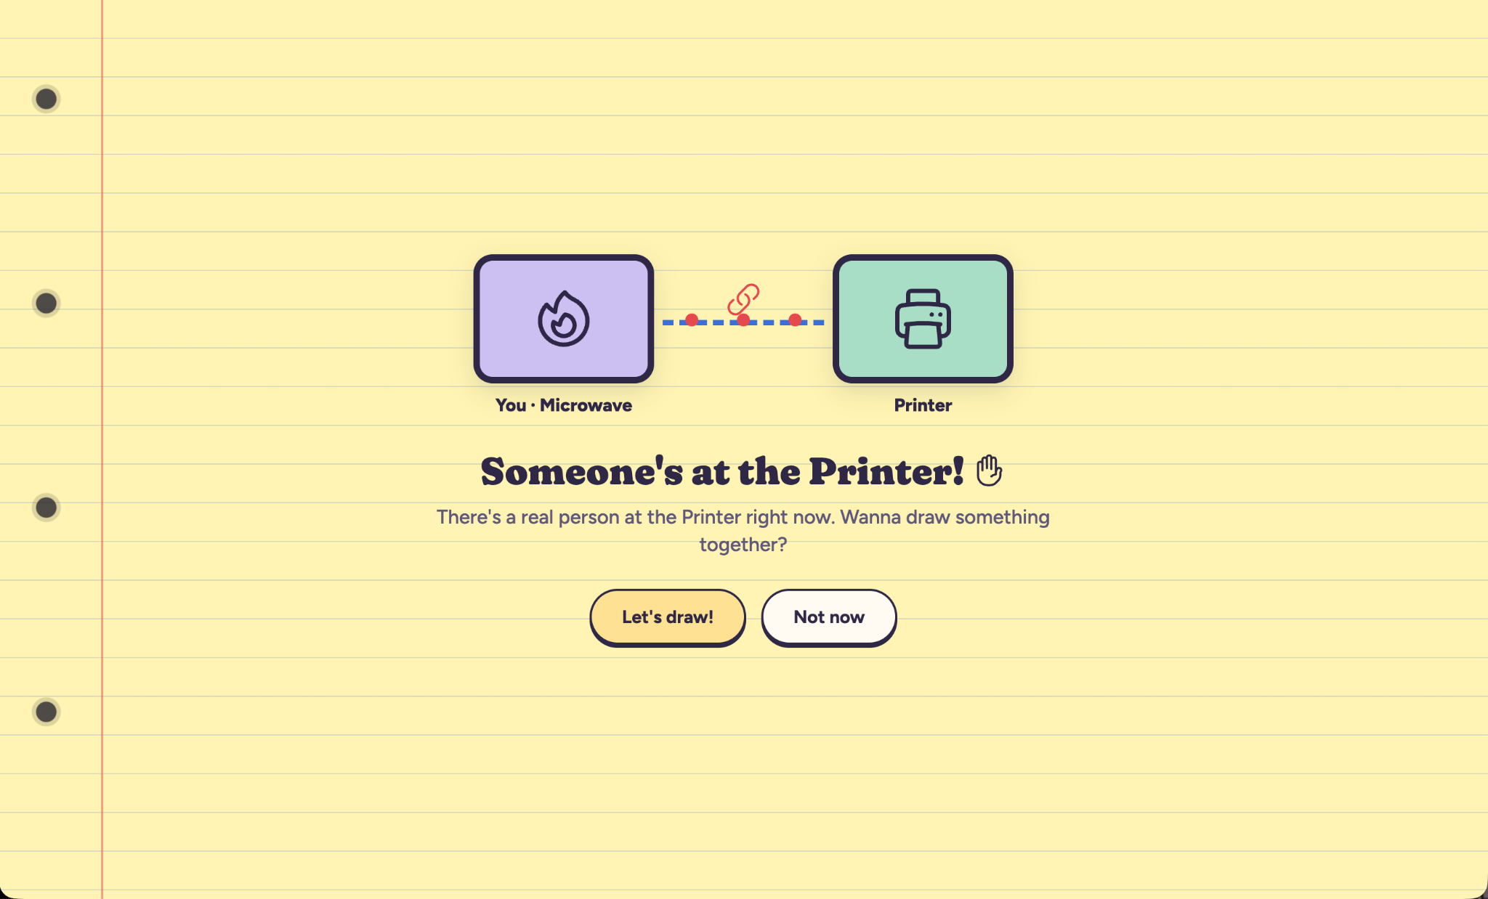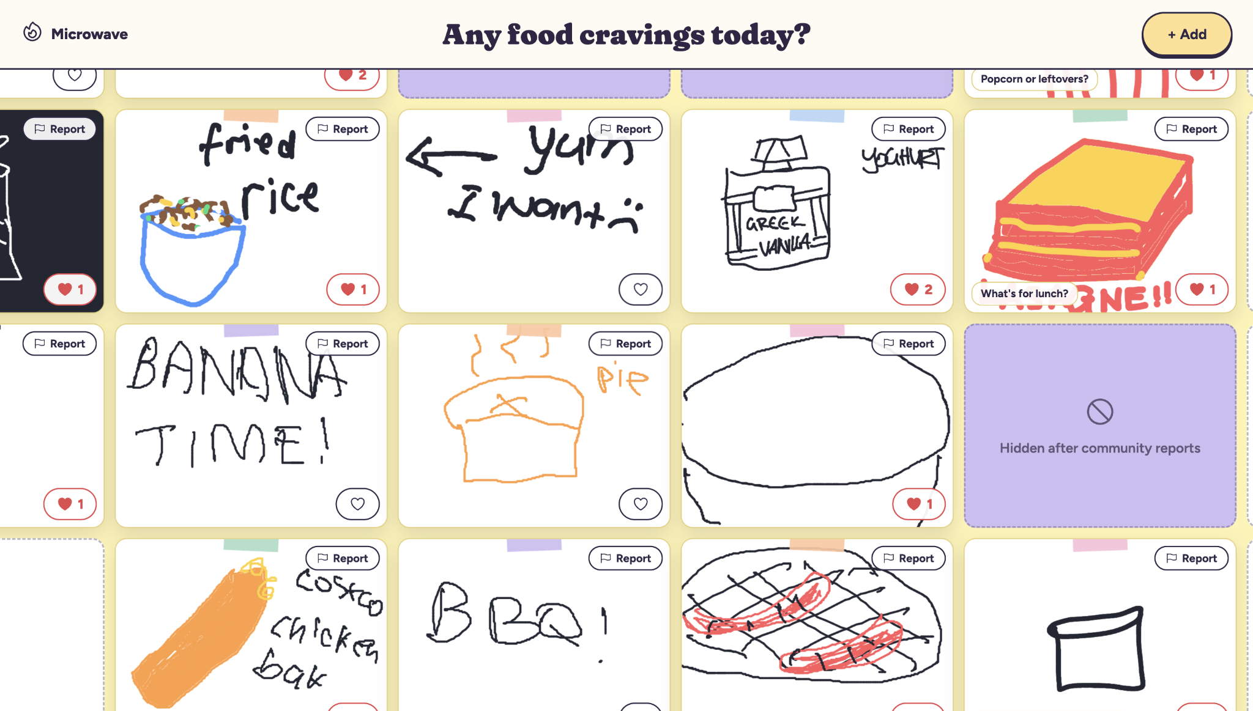
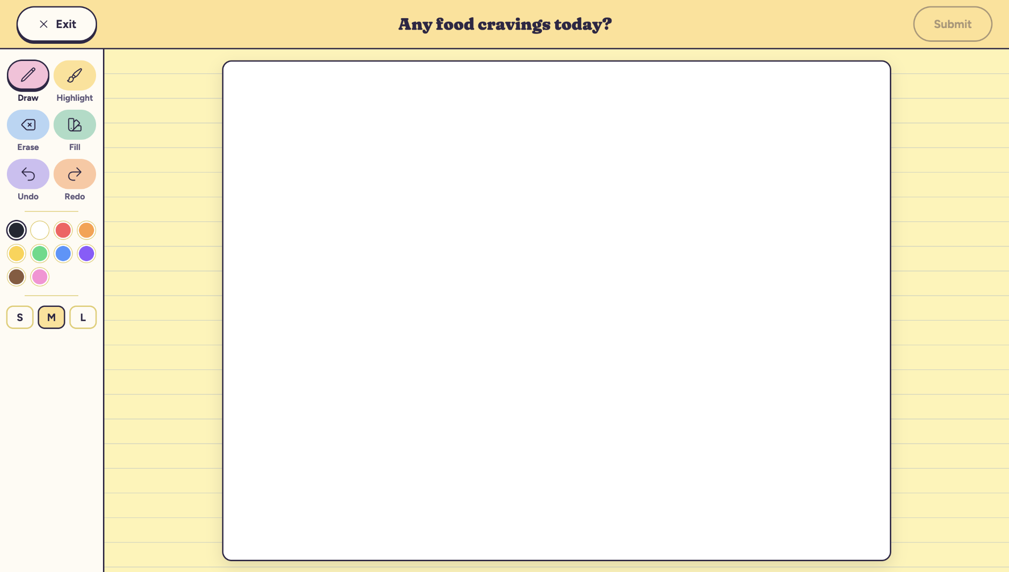

Domain Research
We started with low-stakes networking through shared interests. However, inspired by the Portal project, which links strangers in different cities through live video, we shifted towards unplanned, chance encounters. Research into prior attempts shaped this direction, where Sketching with Strangers showed strangers connecting through drawing alone and Next2You used a progressive reveal to build familiarity in low-stakes stages. Our Week 5 time-space matrix drew on these ideas, and the message trail and real-time connection shaped our final design.

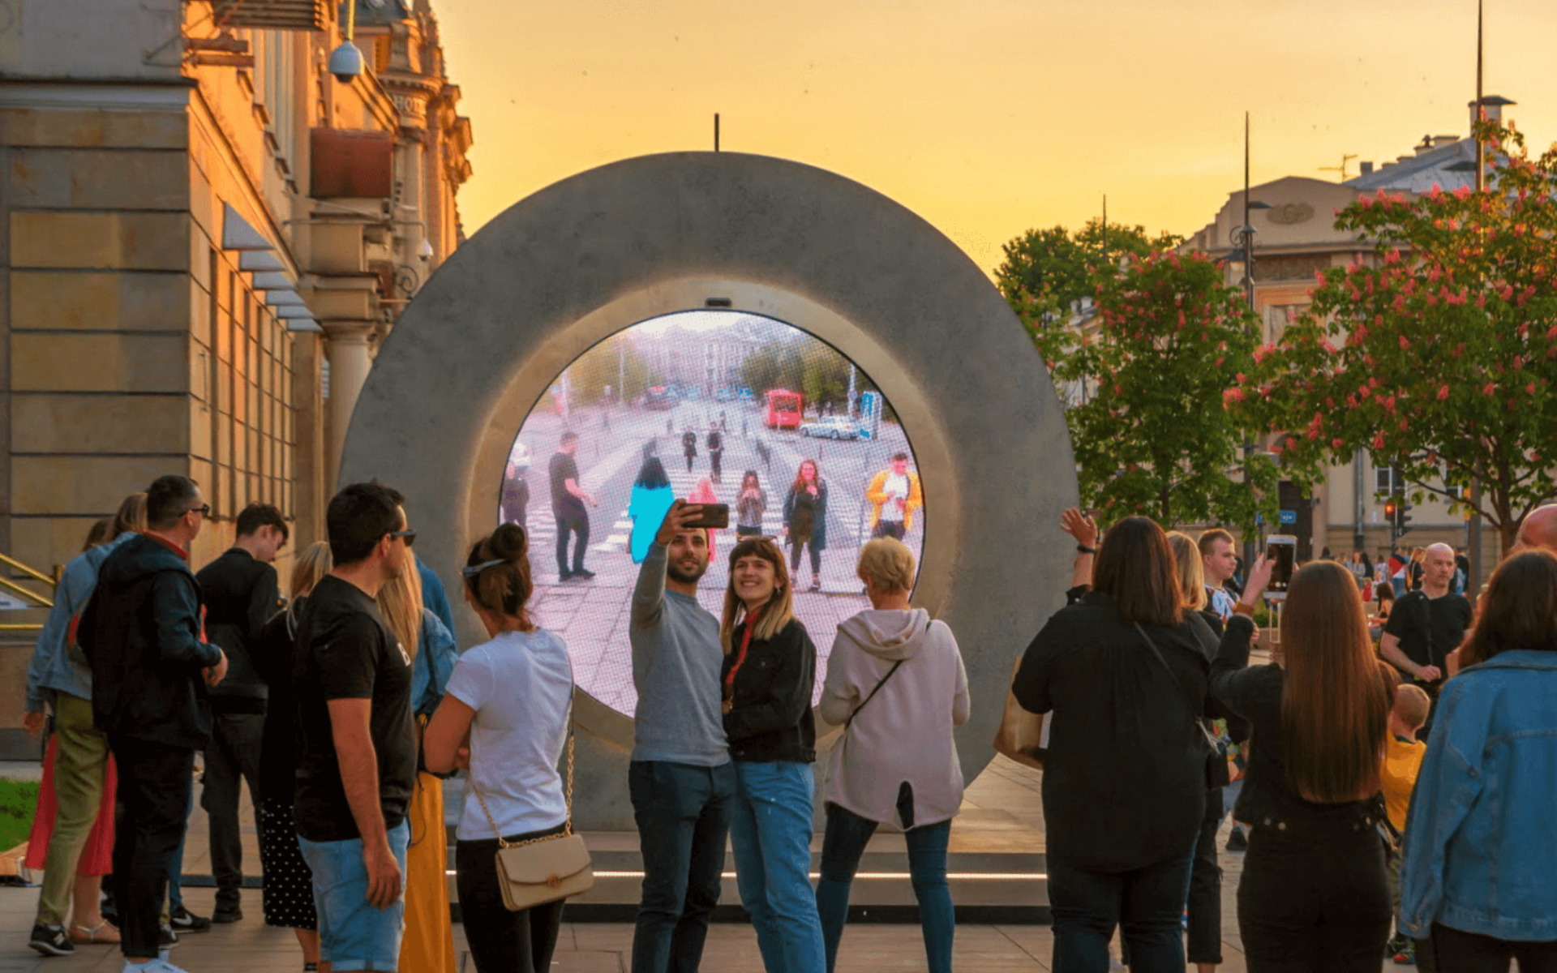
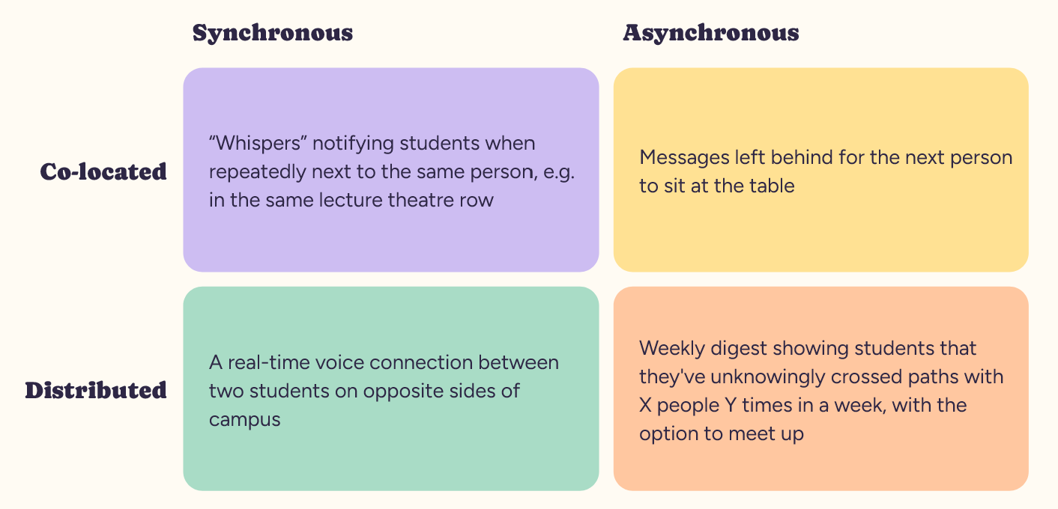

Preliminary Interviews
We interviewed six students about their experiences with strangers, avoiding design ideas so we could understand the problem first. Participants wanted connection but lacked a reason to start it: “There just aren’t enough excuses to actually talk to people.” Overall, it seemed that students were open to connecting with strangers but lacked a meaningful platform or way to do so.

Probes
To see whether students would contribute to a message board, we left a broad “Leave a message for the next person!” sheet at the Dorothy Hill library printer from Friday to Monday, with three starter messages so it wouldn’t look empty. Students replied to these and to each other, including wishing a student “Happy Birthday”.
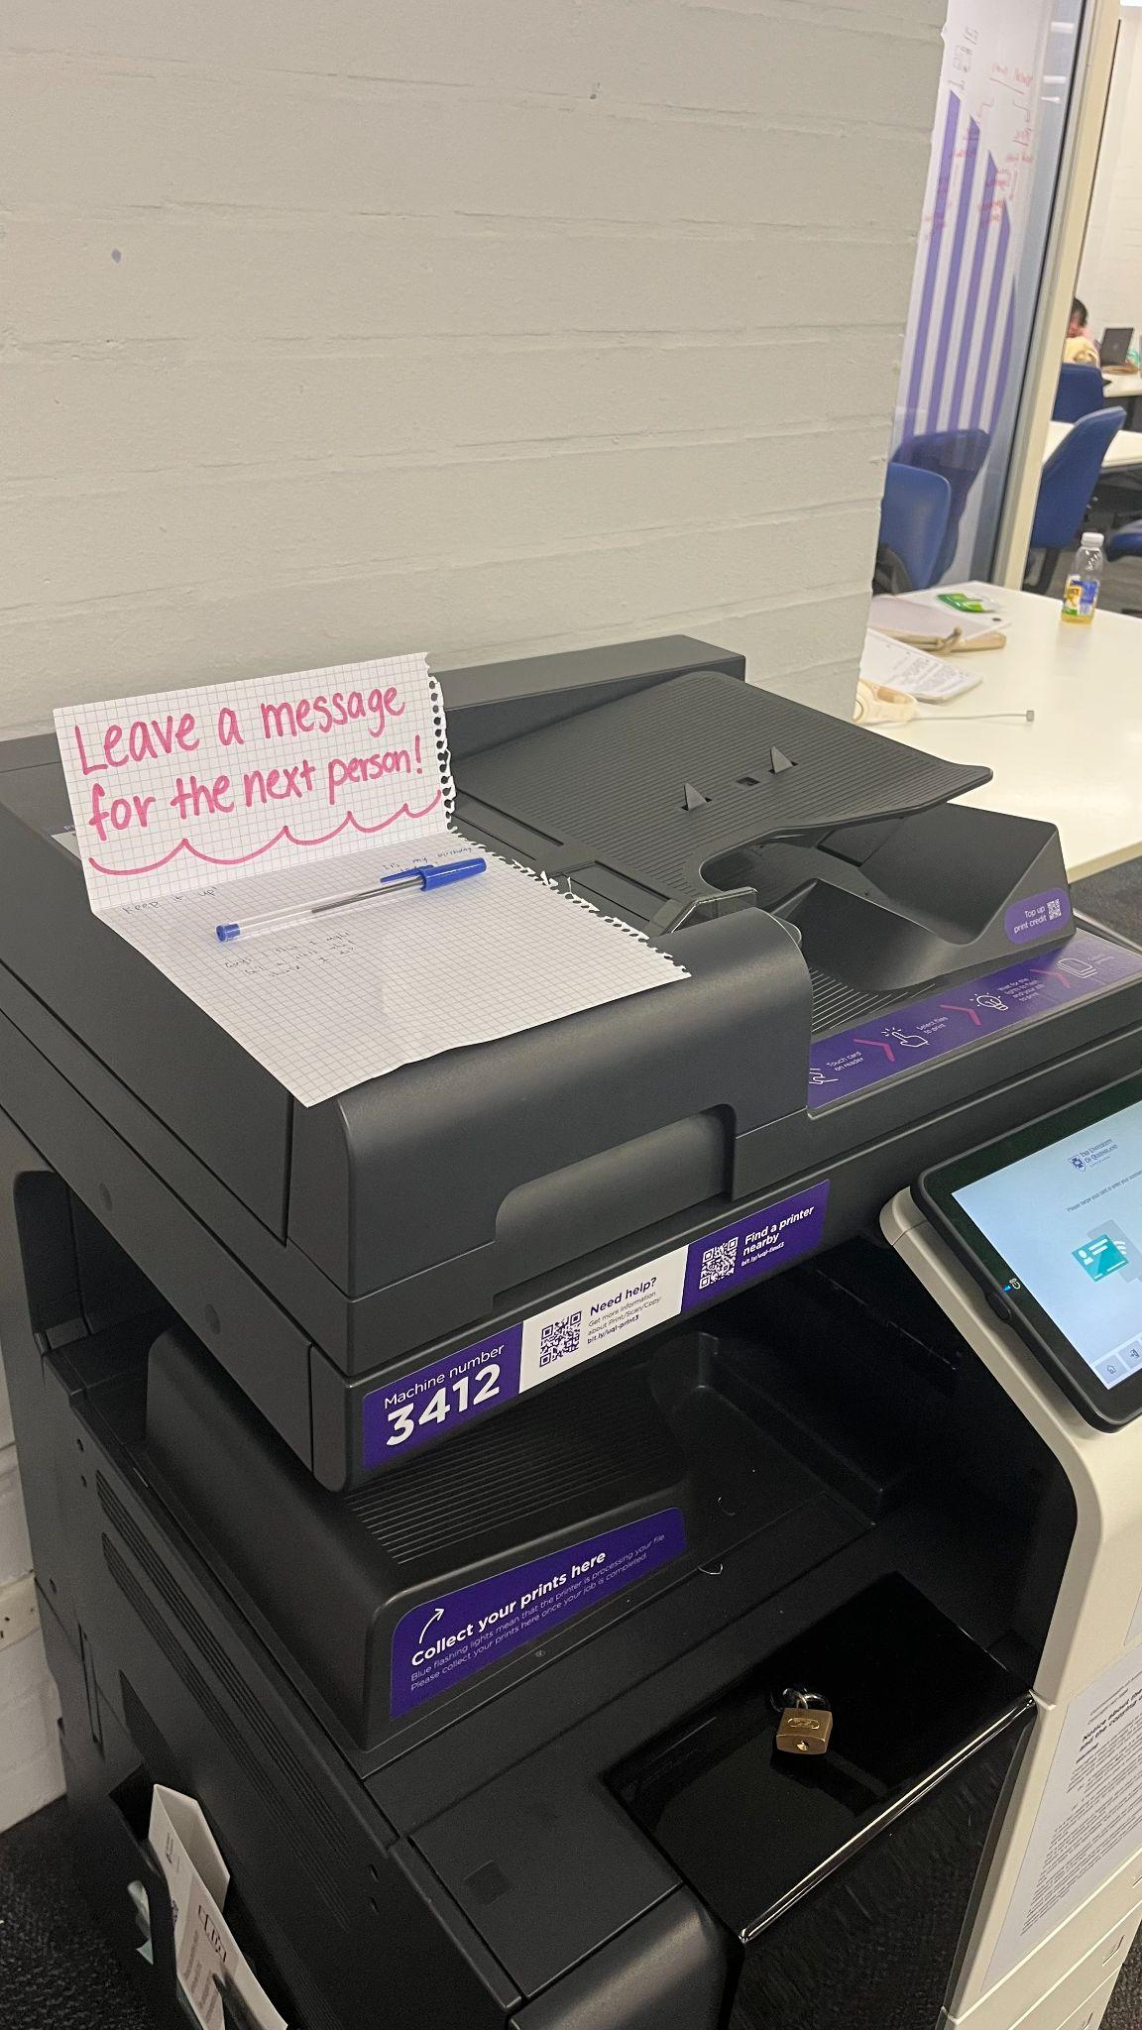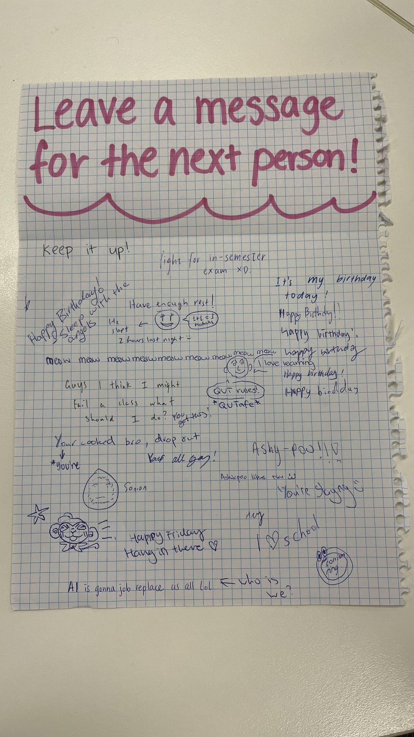

We then tested “Leave a secret!” by the library microwave and “Add to the drawing!” at Central library’s printer, each for two weeks. Secrets ranged from jokes to personal admissions, so anonymity let people share more than we expected, while the drawing sheet filled with playful images. Field observations at the microwave validated the natural waiting spot, as people noticed the sheet while waiting and rarely sought it out. It drew many responses within two days and no visible negative reactions. From these probes, it was clear students were interested in participating in a co-located message board activity, and actively engaged with one another asynchronously.
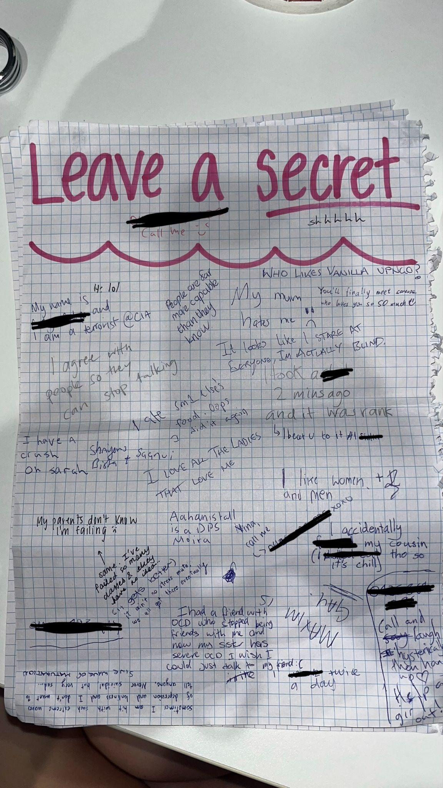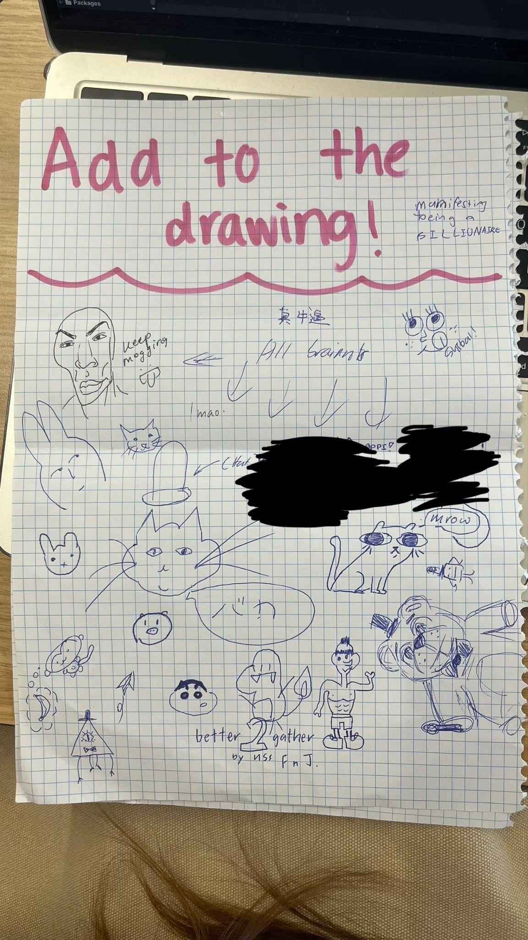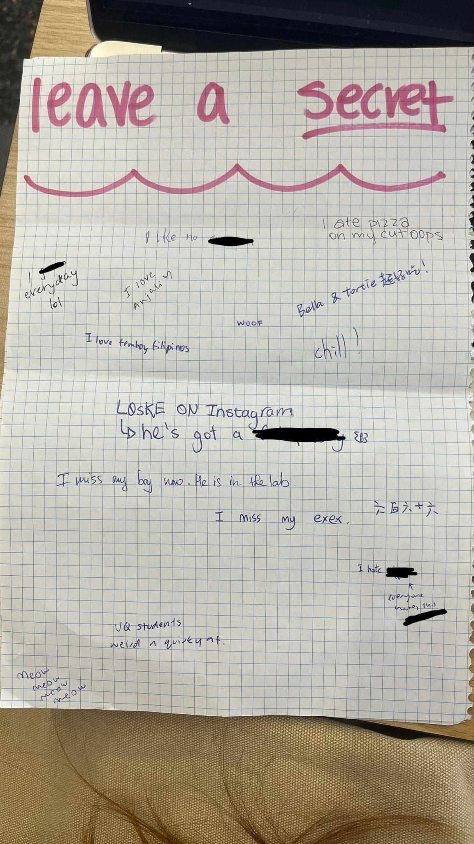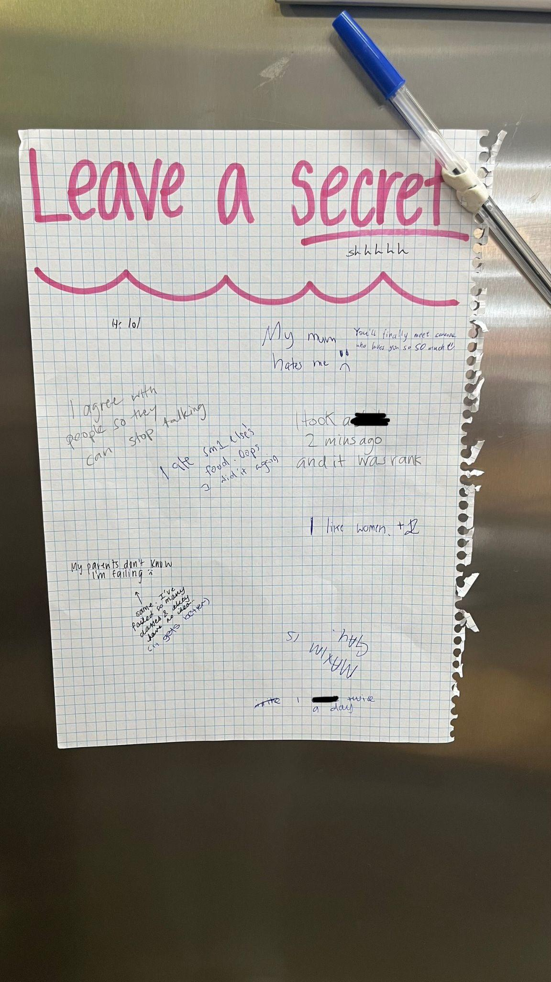

Secondary Interviews
We interviewed nine students to test the concept and coded the findings using the COMB-B model. Participants said campus habits work against casual contact, where “Everyone’s always going somewhere…on their phone, or with headphones in”, and even curious participants would only engage with something they came across, not go out of their way for. We found that shared activities consistently reduced awkwardness through a participant mentioning it is “way less awkward than if we’d just been standing around trying to make small talk”. Because shared activities felt less awkward than conversation, we turned the proposal’s voice connection into drawing together, and kept the message trail as our message board.
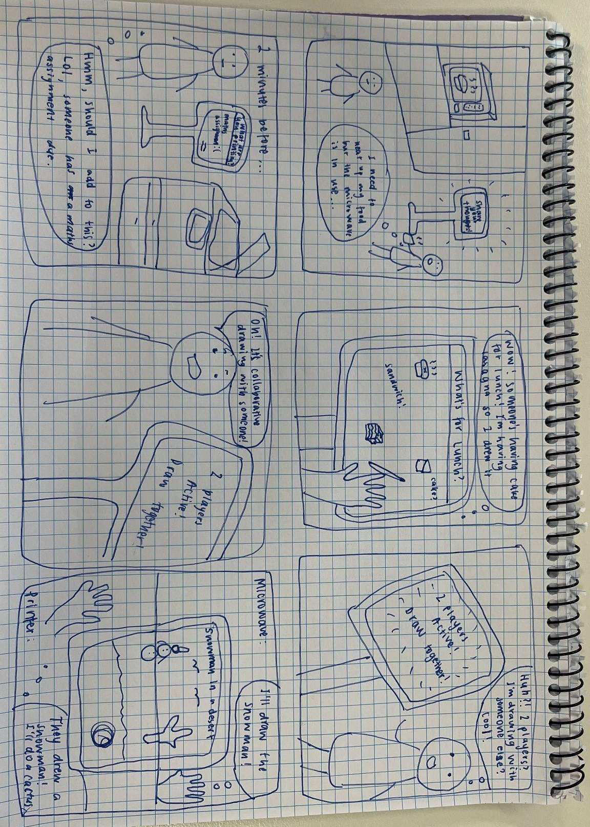

Prototype & Testing Sessions

The minimum viable product (MVP) was built around three core features.
- When only a single tablet is active, users must be able to view and respond to a location-based prompt.
- When both tablets are active at the same time, users enter a shared collaborative drawing game.
- Once the game ends, users must be able to save their finished artwork.

Using the 3C model, the message board supports communication, as strangers exchange drawings and messages over time. The turn-taking timer supports coordination, structuring who draws when. The shared canvas supports cooperation, as both people build one drawing together. Seeing the other person’s strokes appear live also gives each user awareness that someone real is on the other side.

We ran 9 testing sessions in 3 stages using different prototype versions. Two participants drew together in Apple’s Freeform app, knowing they were drawing with a stranger, before we built anything. Five sessions used a Wizard of Oz setup with our functioning prototype: a participant was told they were testing a message board while a teammate secretly used the second iPad and triggered live drawing, so the connection was a genuine surprise. Two final sessions took place in the real settings, a kitchen area and a printer, with each participant paired with another tester rather than a teammate.

What we found | What we changed
Freeform participant suggested alternating to facilitate cooperative and coordinate drawing | Turn-taking with a timer
Responses on the message board felt “very isolated… there’s a border around everything and it feels far apart” | One scrollable, zoomable grid, where tapping an empty square expands the canvas
Participants missed the back button and had no way to leave: “I would have loved to have a back button” | Exit buttons between every state
Participants skipped the instructions: “No one reads the instructions” | One short instruction card with images.
Observations noted that different prompts (“clock”, “owl”) made one shared picture hard | Both people get the same prompt, e.g. “a snail on a train”
Ethical concerns consider the implications of inappropriate content submitted. Probes also showed that content moderation needed to be implemented. | Added a community report button so users can flag inappropriate content
Transition into live drawing was a surprise, one participant thought the other person was prerecorded | Animation showing someone at the other tablet and a session about to begin

Real-world testing suggested the iterations worked. One participant stopped because of the colourful design and an already full board, the other while waiting for her food. Neither knew what it was straight away, but both worked it out from the existing drawings. Both found the move into live drawing clear, and she would use it again because she is “not doing anything while I’m waiting for my food”. Both wanted to know more about their partner, such as a short chat. However, with only two real-world sessions, so we cannot yet say how often live drawing would happen by chance. Next steps include a longer deployment, an opt-in short chat after each drawing and automated content screening.
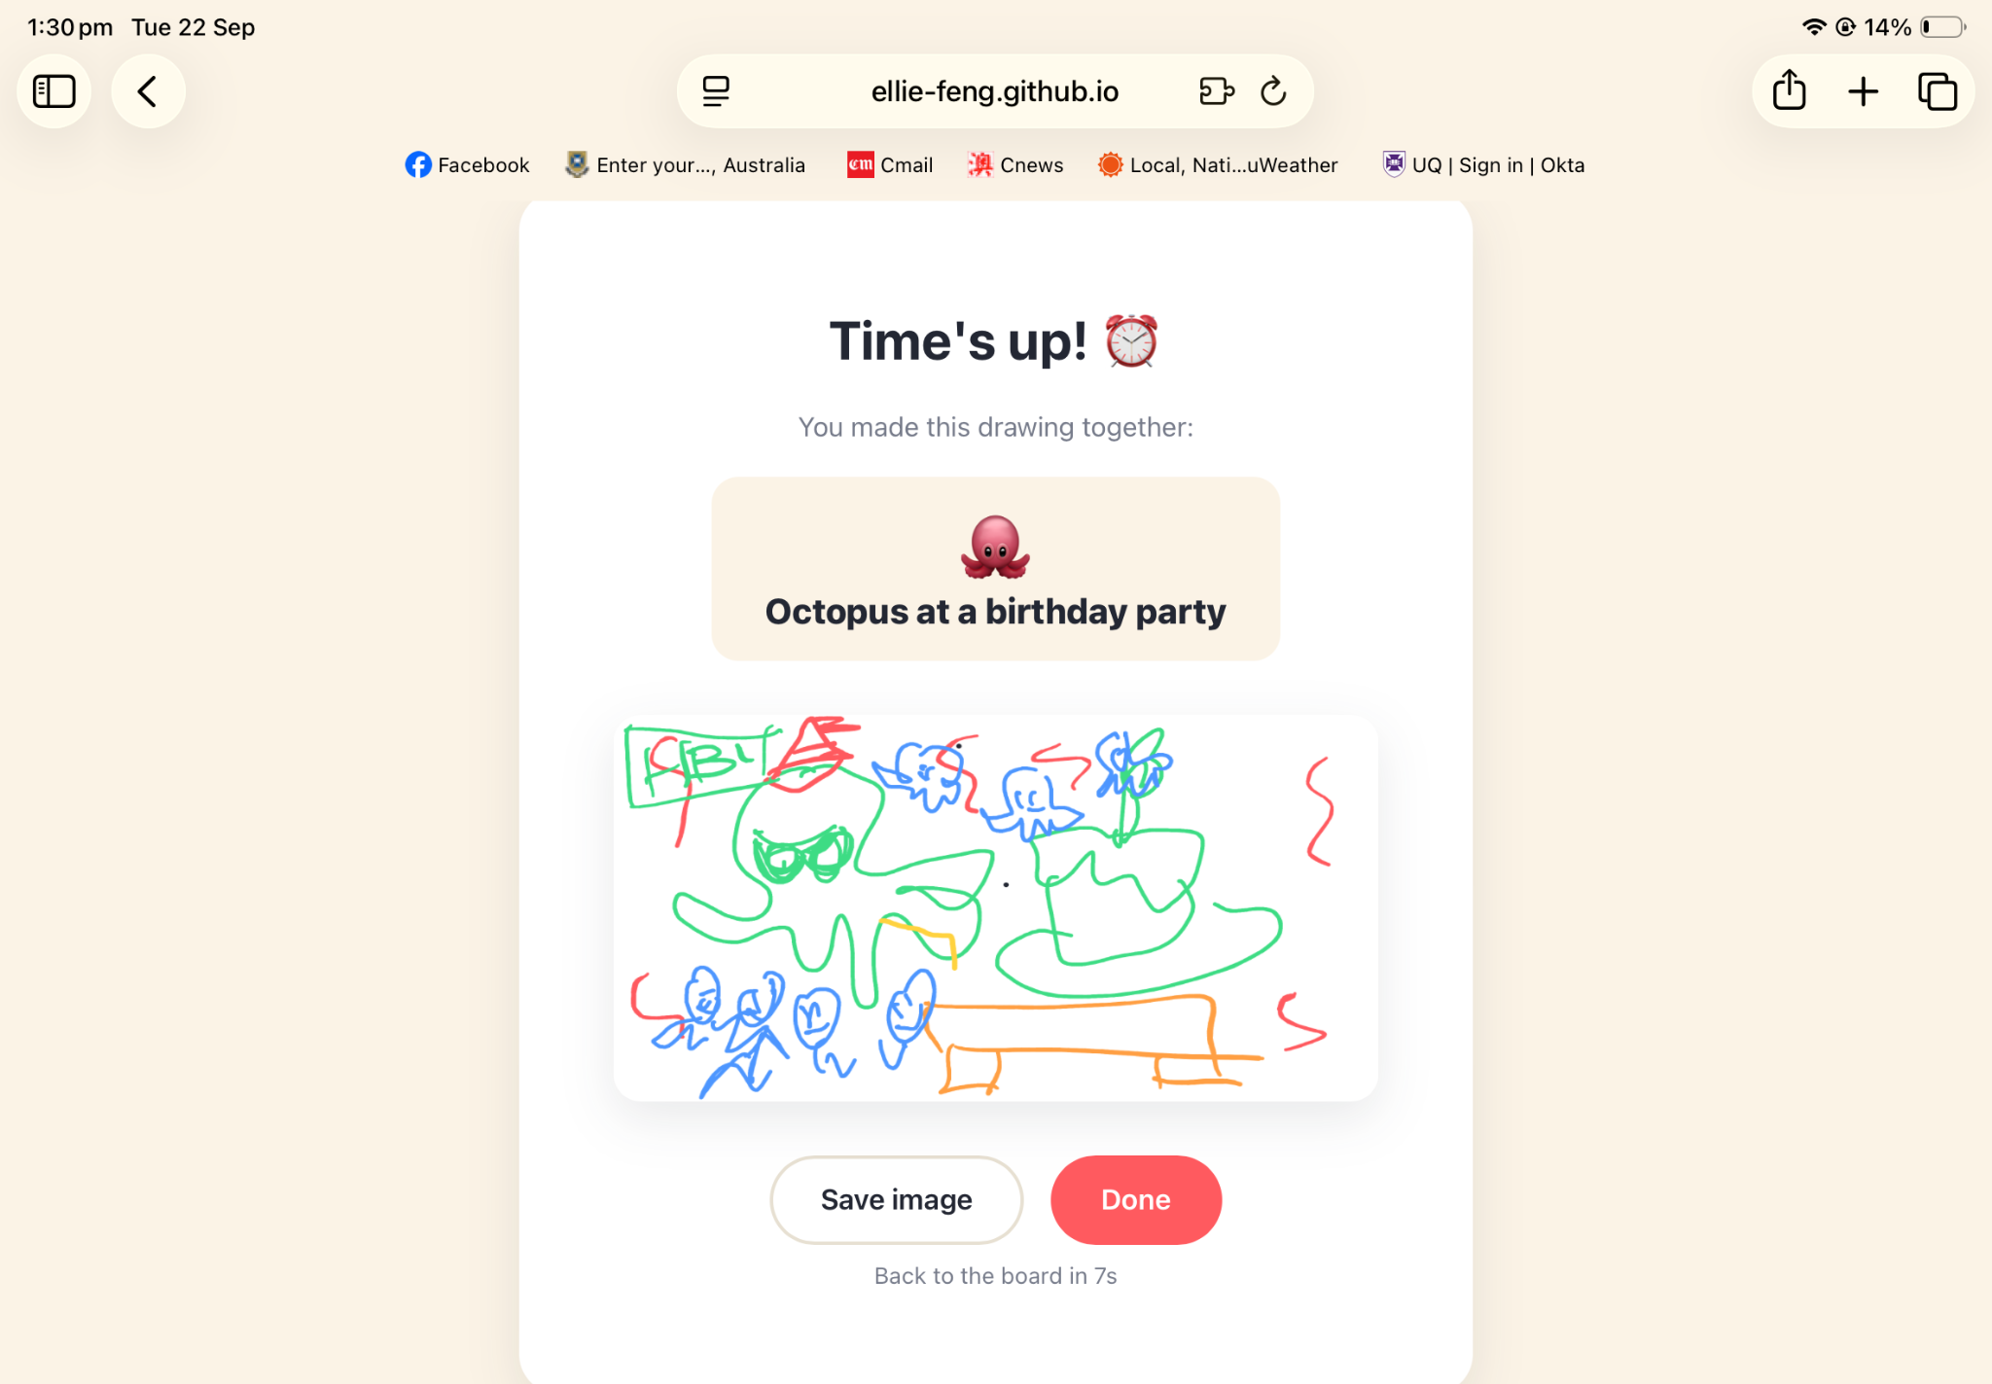
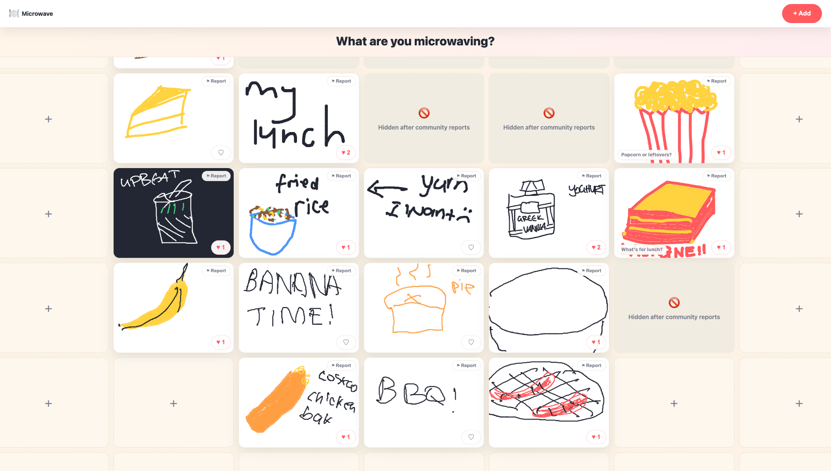

Team Member | Contributions
Ruby | Domain research, Preliminary and secondary interviews with 4 participants, Probe distribution & collection, Field observations, Facilitated 7 testing sessions, Testing session post-interview with 7 participants, analysis & evaluation, Google Doc documentation & organisation, Design Process Overview, Tradeshow Poster, Pitch Script
Ellie | Domain research, Preliminary and secondary interviews with 4 participants. Probe distribution & collection,Testing session post-interview with 7 participants, Real-World Testing with 1 Participant, Analysis & Evaluation, Facilitating testing sessions, Functional Prototype, Github Organisation and Documentation, Design Process Overview, Tradeshow Poster
Bianca | Domain research, preliminary and secondary interviews, interview transcript collation, analysis, and evaluation, Google Drive/GitHub documentation and organisation including planning and organising meeting minutes, Design Process Overview, pitch script, Tradeshow Poster
Emily | Ethical Considerations Wiki, Preliminary and secondary interviews with 4 participants, Facilitating 4 testing sessions, Poster Design, content and execution. Future design opportunities.
Reyana | Domain research, Preliminary and secondary interviews, Real-World Testing with 1 Participant, Analysis & Evaluation, Assisting Testing Sessions, Tradeshow Poster

